**CSD2550 Web Applications and Databases**

**Coursework two**

**E-commerce website**



**Yaser – M00568885**

**Alex – M00576475**

**Jovanie – M00577156**

**Introduction:**

In this project report I will be describing, presenting and explaining our e-commerce website including the progress of the website and futuristic amendments. To create a successful e-commerce website a great amount of thought has gone into the design and product choice as well as shared work load and team deadlines.

**Description:**

Through lots of thoughts and decision making as a group of three we have come up with the idea of an e-commerce website which is intended to sell “Headphones”. Nowadays headphones are used as essential accessories by millions of people. From its design to its great sound quality and usability. Possible sales may by for personal use, gifts, office and business and even for schools.

**Website:**

Our website is strictly made to be user-friendly as well as attractive to enhance the interaction between the customer and their needs. The website begins with an expertly made interactive homepage where customers get a clear view of what we provide “headphones” as well as a JavaScript slide show of our most sellers. A simple navbar is placed at the top where users can move from page to page depending on their request. From homepage to store page or even about us page. At the top right there are buttons for login, registering and basket. By clicking on either Login or Join a form will drop down asking for user details, either for logging in or making an account. Registered users will be able to add products to the basket as well as edit their orders, add more to the basket, remove products from the basket, change their personal details such as delivery address and make an order/purchase. There is a second bar which has our Logo as well as a search engine. The purpose of this search engine is to help customers who are looking for a specific product, be able to find that product easily. Just by typing letters the search engine will narrow and preview the product or similar products. The homepage also displays brand logos where customers can click on if they wish to view the specific branded headphones we have available.

Our shop page is well designed for easy interaction, products are clearly visible in single boxes, each product box contains an image of the product, price, rating and two buttons one for adding product to basket other to view more information. Once a more information button is clicked the product box expands and displays an image as well as detailed product description, customer reviews, add to basket button, product ID and a link to a full video of the product.

Orders, once customers are logged in they can add products to their basket, confirm their order or remove the product from the basket. Our page will work in sync with the Database we have implemented using MongoDB. Customer information will be stored to keep their details once they are registered as well as product orders. We will also store their order details to be able to give recommendation for other products that we provide. To give recommendations we must know what the customer is into

**CMS:**

We have also managed to design and create a Content Management System to run our e-commerce website smoothly. It has a sufficient user-friendly interface that allows admins to view our product range, add/edit/delete products, add more stock to products as well as manage customer orders. The system can only be accessed by admin users for safety and security reasons, customer details are stored with product orders so that admins can help customers with their order enquiries.

**MongoDB Design:**

Our MongoDB structure has been designed with four different databases; products, customers, orders and shopping cart “basket”, therefore each database contains a certain number of collections. The number of collections that we want to create in our database could vary as it will depend on how we want to store the data.

In the following we will be demonstrating how our database will look like, to present this, we will provide a brief explanation of every collection along with some screenshots.

**Database list:**

* Products
* Customer
* Orders
* Shopping Cart

**DB Products:**

Collection – “Headphones” Here is a screenshot of our product. On each description there’s an ID number assigned to each product which later will be used to identify the products that a customer has bought.

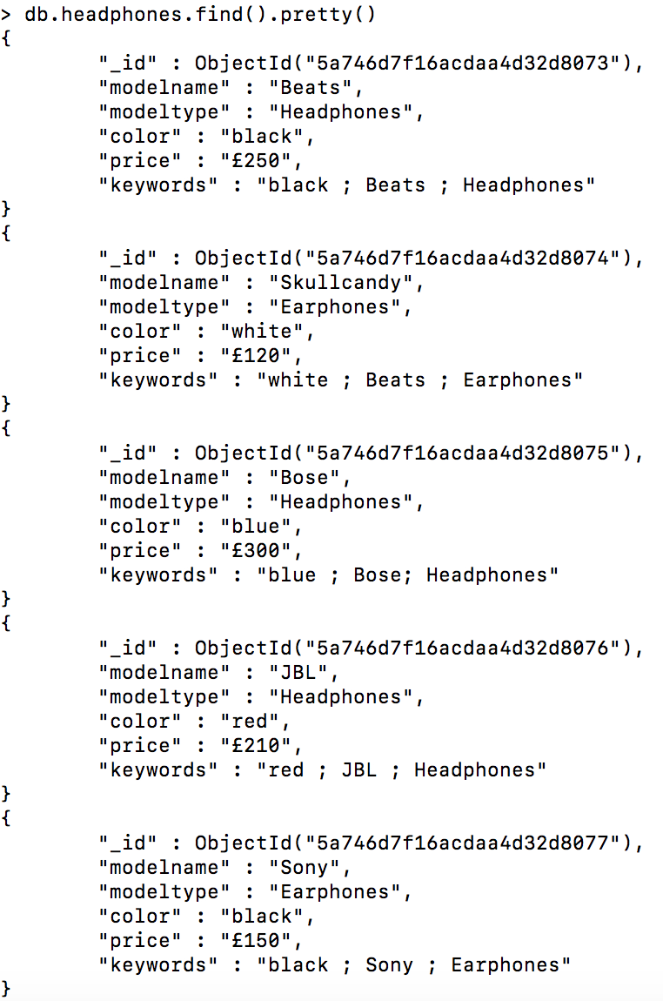

**DB Customer:**

Collection – “Customer” The next screenshot illustrates the personal details of our customers; this information will be saved in our database when the final version is made.

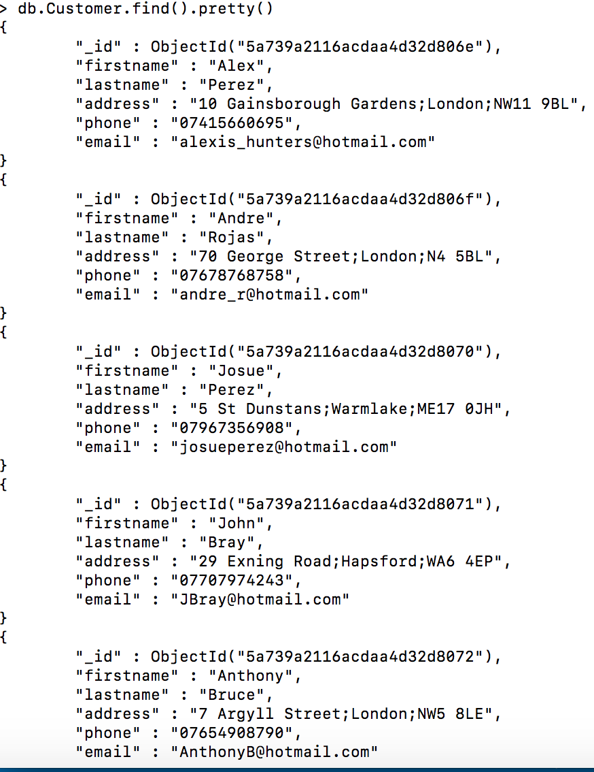

**DB Orders:**

Collection – “Orders” When customers have made their order/purchase, immediately we will obtain their details. To identify who is buying the product, the order made by a customer will provide us the ID of the person. Besides knowing who is buying the product, we will also know the shipping address, date of the purchase, time, cost of the product and finally the product that the customer is buying.

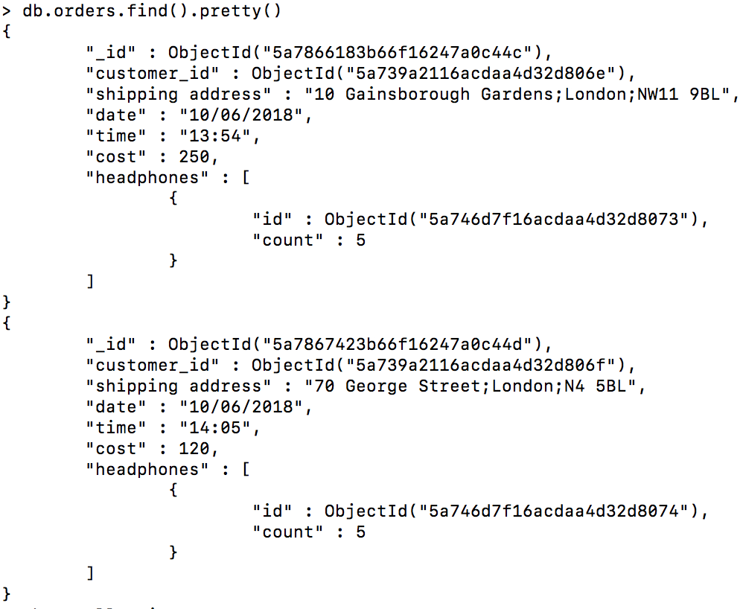

**DB Shopping Cart:**

Collection – “Shopping Cart” This database saves the information of the items added to the cart and not only the product but also the customer, the date and time when it is added and the cost.

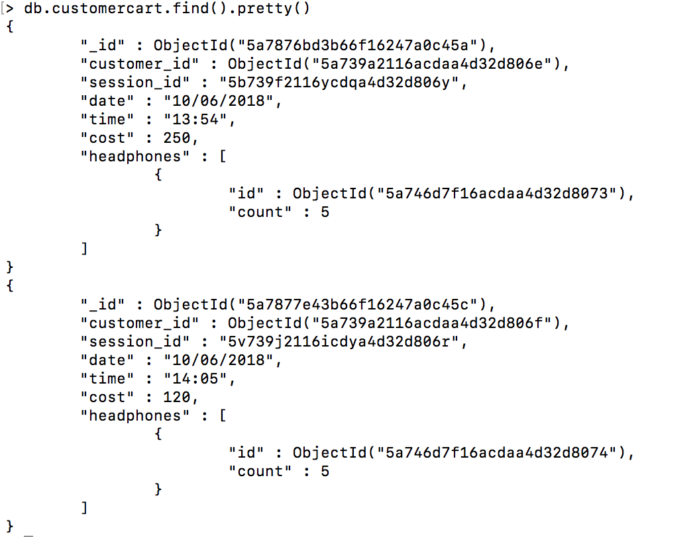

**Status:**

Our current situation as a group is looking sharp. We all met up a great amount of times to discuss the progress of this project as well as leaving feedback of what has been done so far. So, by doing this we have managed to come up with a great design and choice of product. As soon as we all agreed to the designs of both the website and database we started working together. Jovanie implemented the HTML, CSS and JavaScript for the pages, Alex created the MongoDB designs and I “Yaser” put it all together in and created this report. We have agreed to share the marks equally between ourselves as we all put in work to this and we all helped with everything needed.

So far, the front end is completed including the CMS, the database design is ready to be used for actual products, orders and customer details. For the next submission we will sit and discuss again who will complete what and use what we already have, to make a fully functional e-commerce website.

**Website Screenshots:**

Home Page:

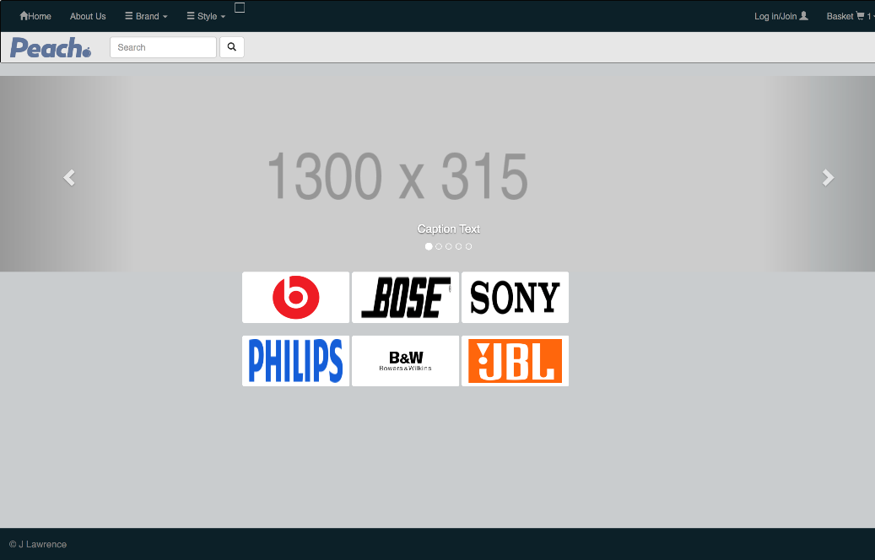

Shop Page:

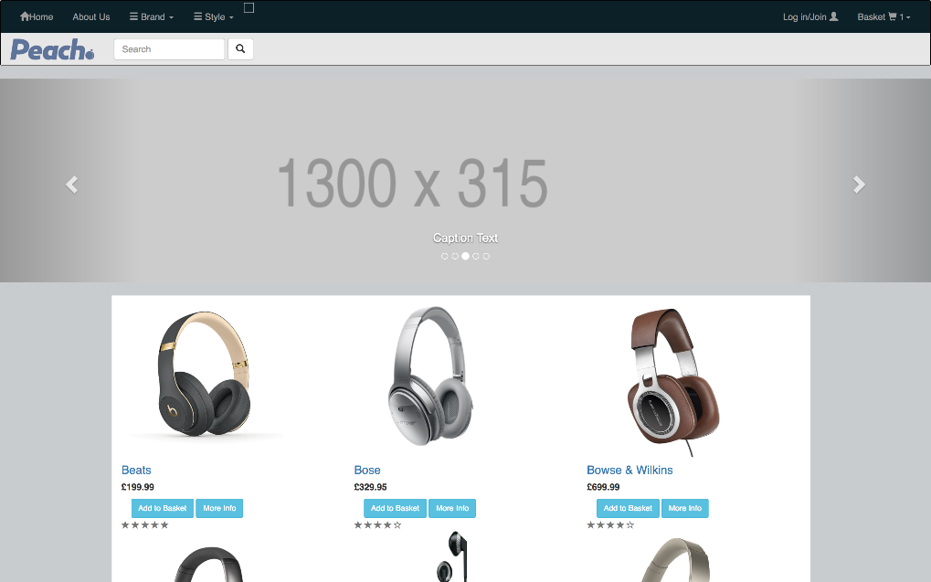

About Us Page:

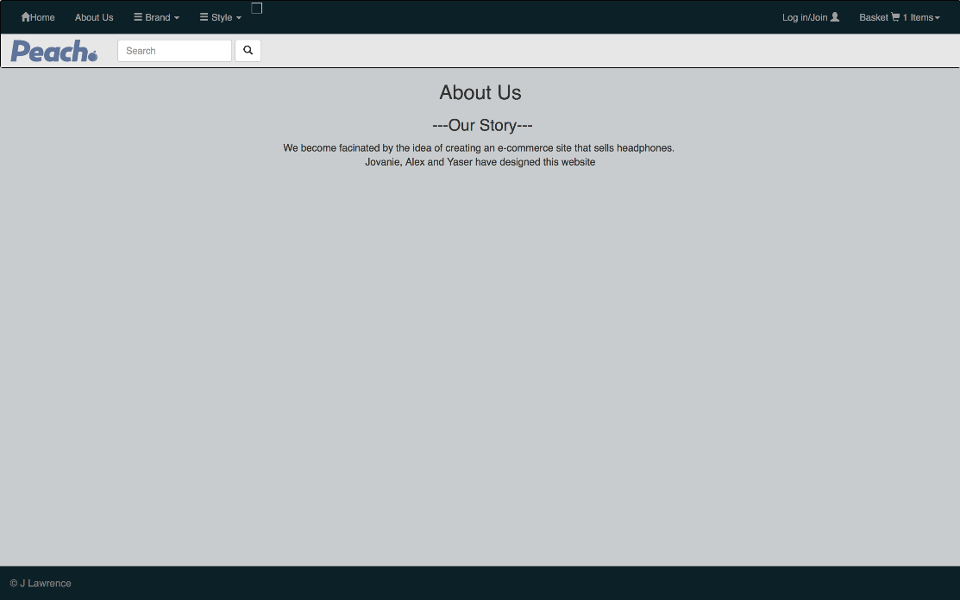

Registration Form:

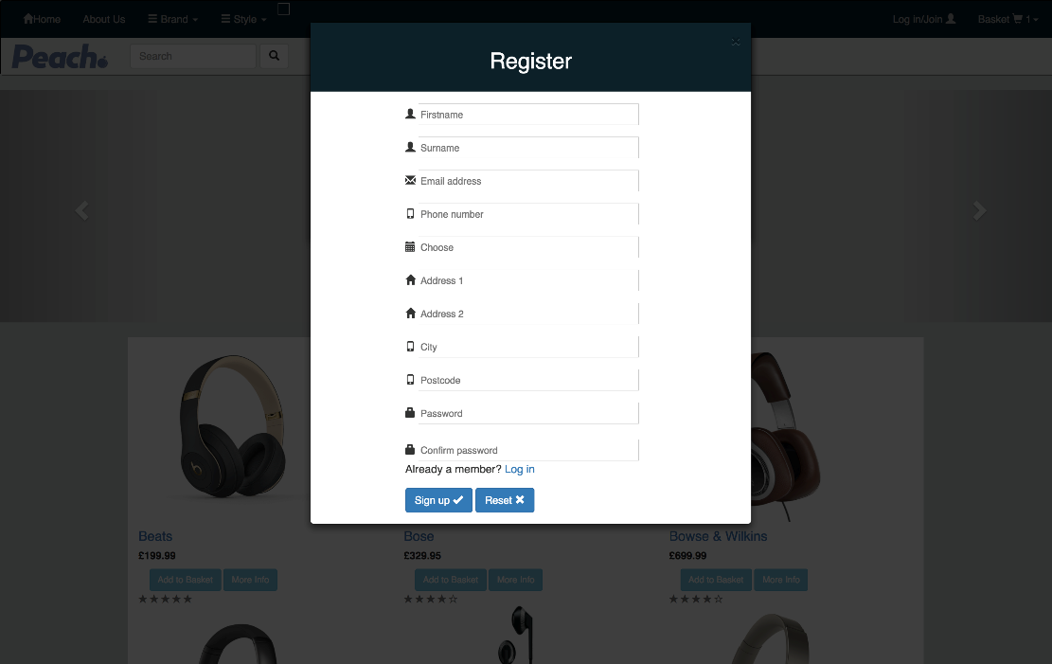

Login Form:

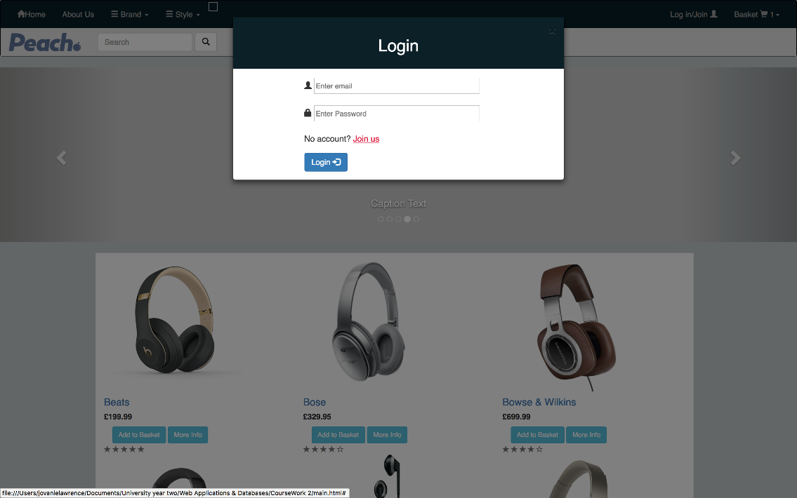

Basket Page:

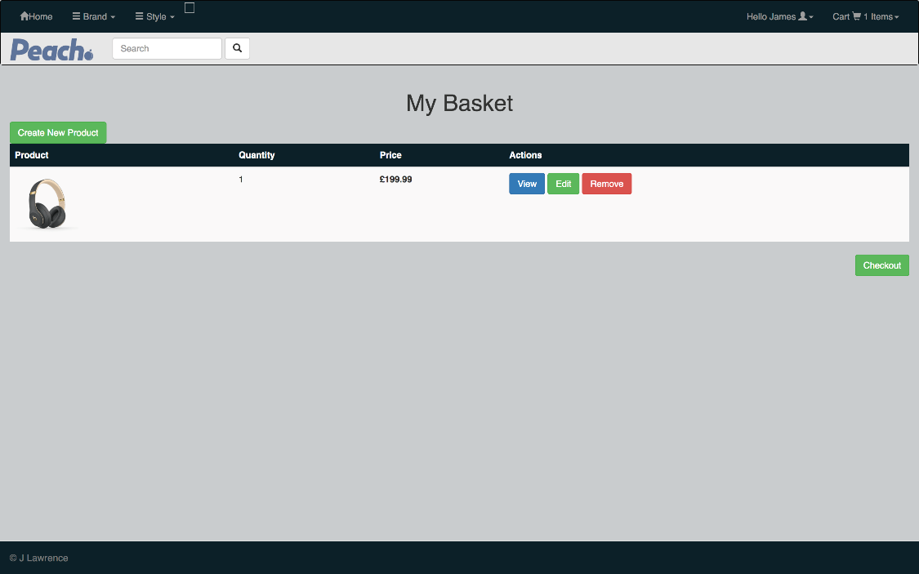

Check Out Page:

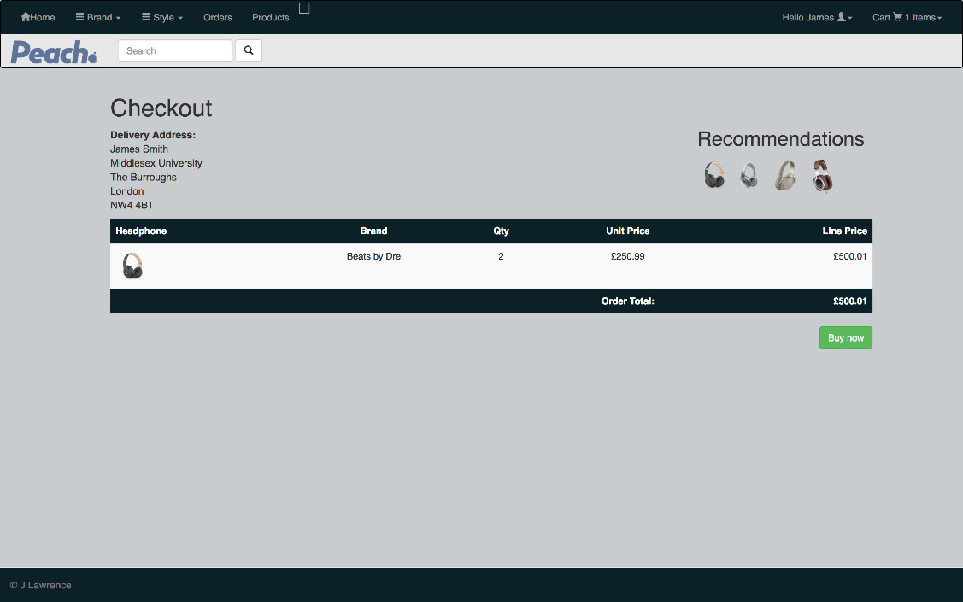

Confirmation Page:

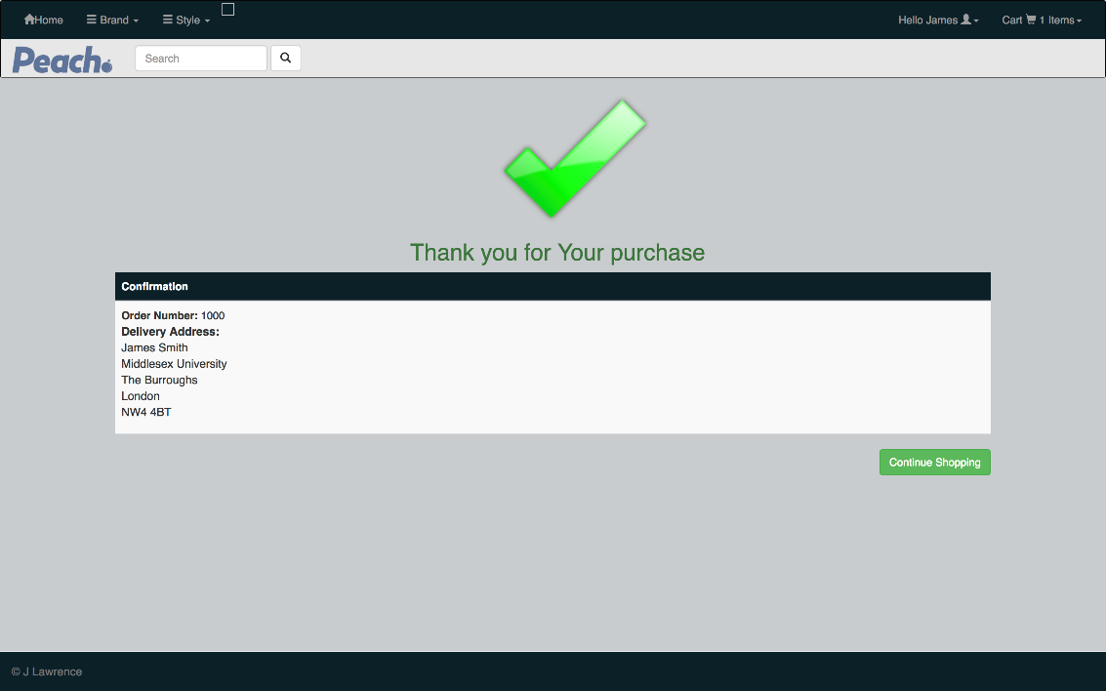

More Information Form:

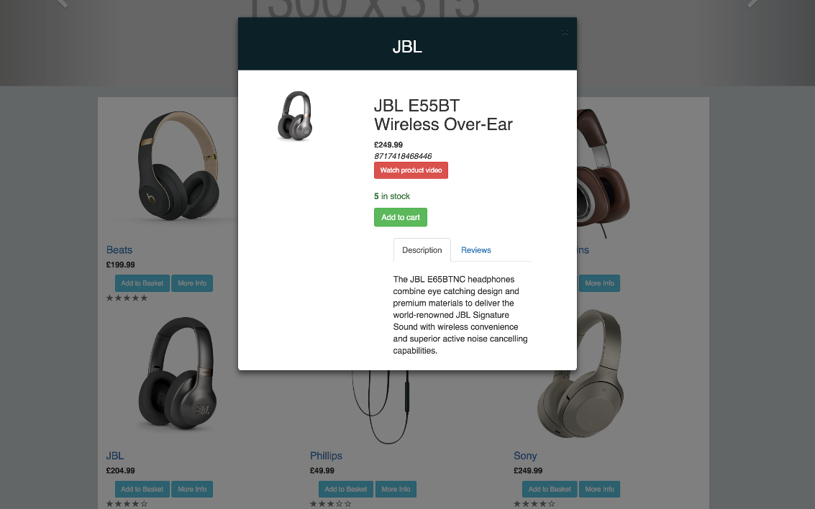

Search Engine Results Page:

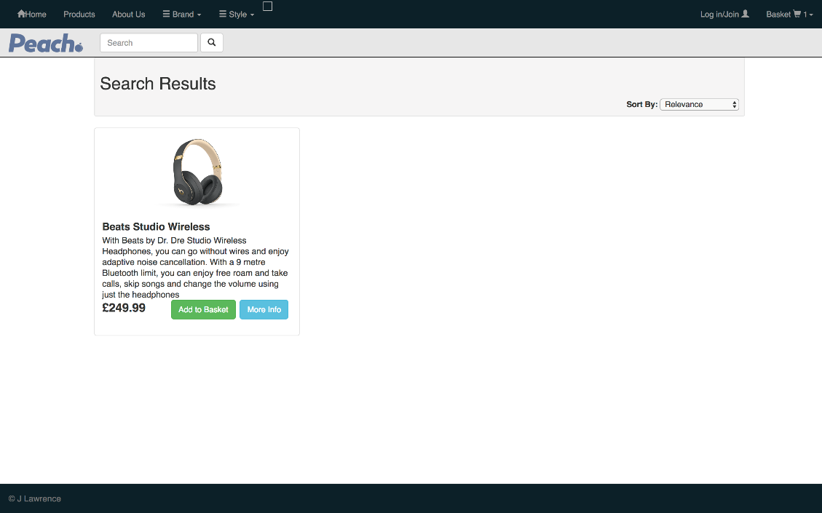

CMS Screenshots:

Login Page:

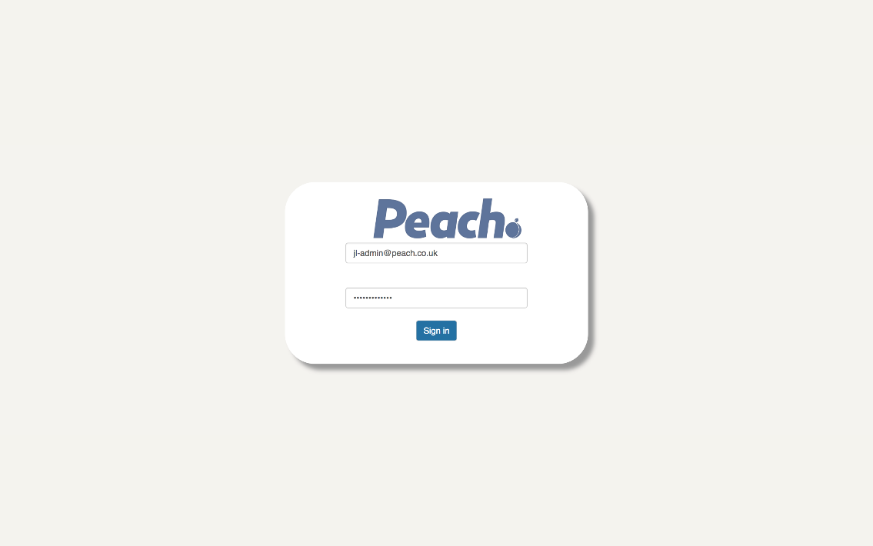

* Note to access the CMS you have to login as an admin!

Main CMS Page:

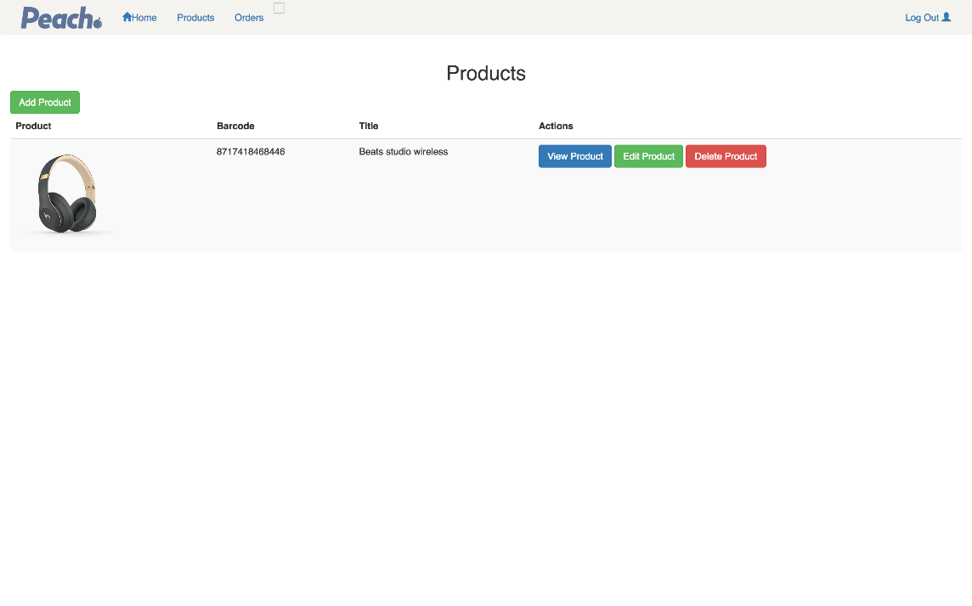

CMS Orders Page:

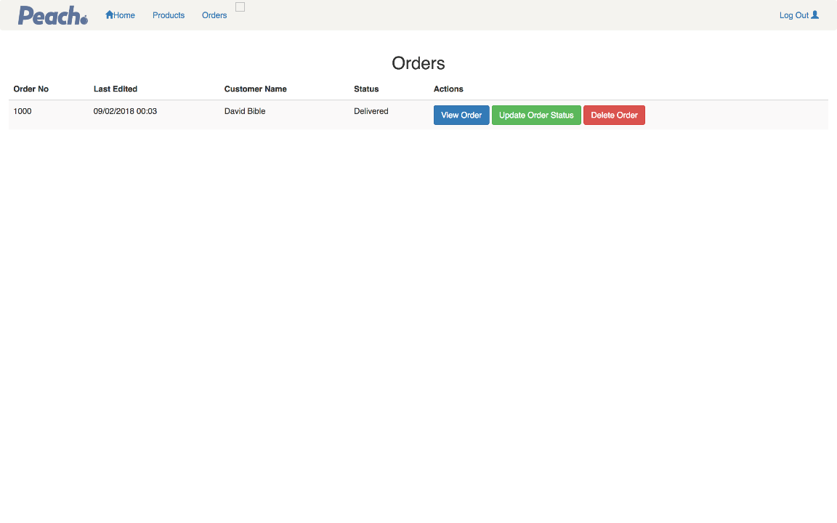

CMS Orders Form:

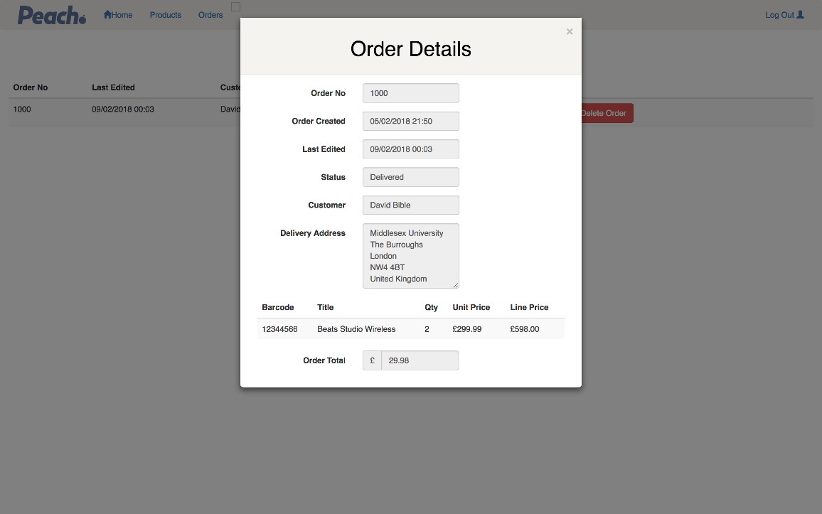

Add Product Form:

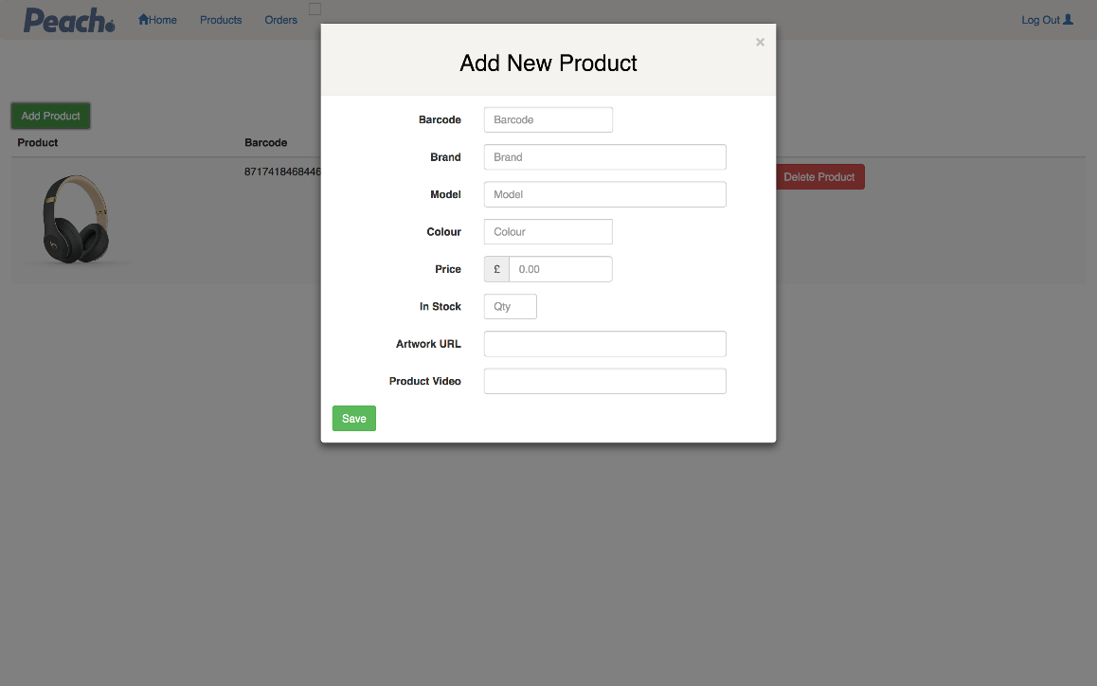

Edit Product Form:

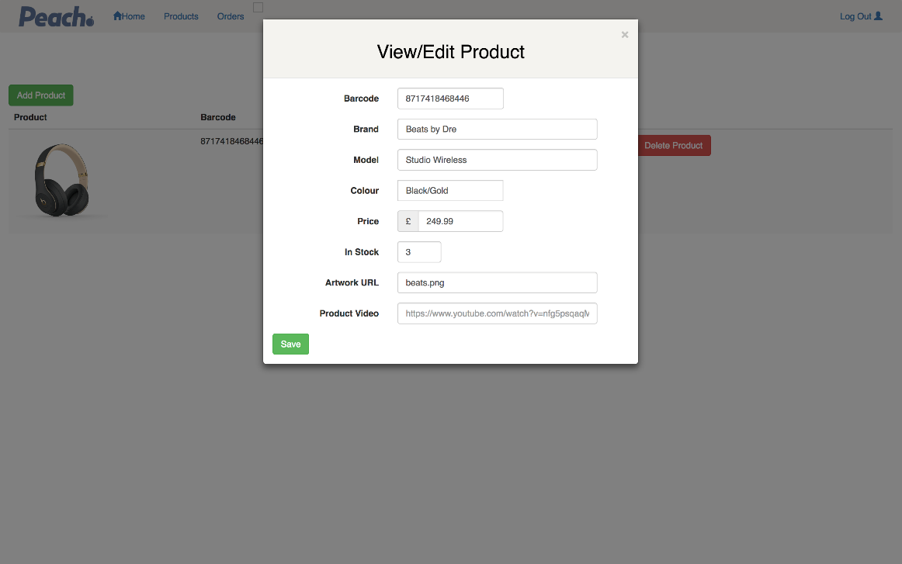

Updating Order Status:

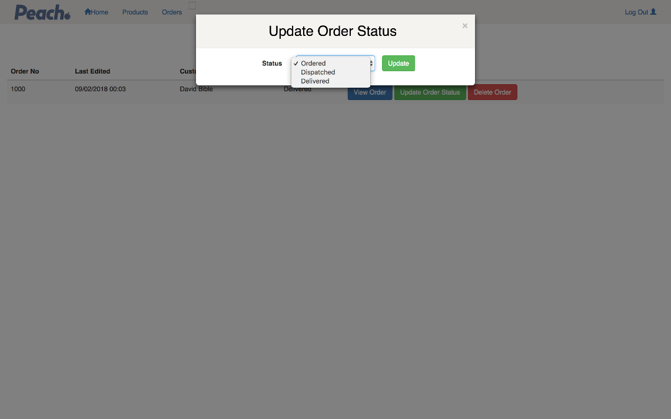

**Third Party Libraries:**

Some parts included Bootstrap and jQuery as third-party libraries.